5. Write a Java program to print the area and perimeter of a rectangle.

Test Data:

Width = 5.6 Height = 8.5

Expected Output

Area is 5.6 \* 8.5 = 47.60

Perimeter is 2 \* (5.6 + 8.5) = 28.20

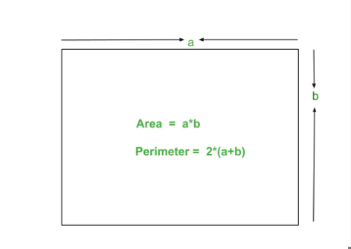

import java.util.Scanner;

public class Exercise5 {

public static void main(String[] args) {

Scanner scnr = new Scanner(System.in);

System.out.println("Enter width");

double width = scnr.nextDouble();

System.out.println("Enter height");

double height = scnr.nextDouble();

System.out.println("Area of rectangle is" +" " + (height\*width));

System.out.println("Perimeter of a rectangle is" +" " +(height\*width)\*2);

}

}